TP3 –Use Case

*Aya Benjelloun*

**Exercise 2 :**

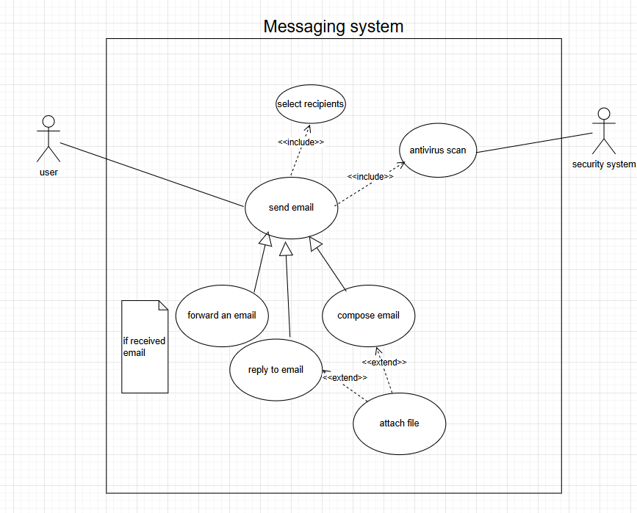

Fig 1 : Messaging System Use Case Diagram

|  |  |
| --- | --- |
| Use case name | send email |
| ID | id1 |
| Brief description | sending an email is the main function of a messaging system, it can be by either composing it, forwarding one received or replying to it. This requires selecting recipients and performing an antivirus scan before being sent. |
| Primary actors | user |
| Secondary actors | security system |
| Preconditions | logged in |
| Postconditions | antivirus scan negative |
|  |  |
| Basic path | to send email : compose email-select recipients- attach file(optional) -perform antivirus scan |
| Alternative path | to send email by replying to another one received or forwarding it |

Fig 2 : Use Case Send Email description attributes

**Exercise 3 :**

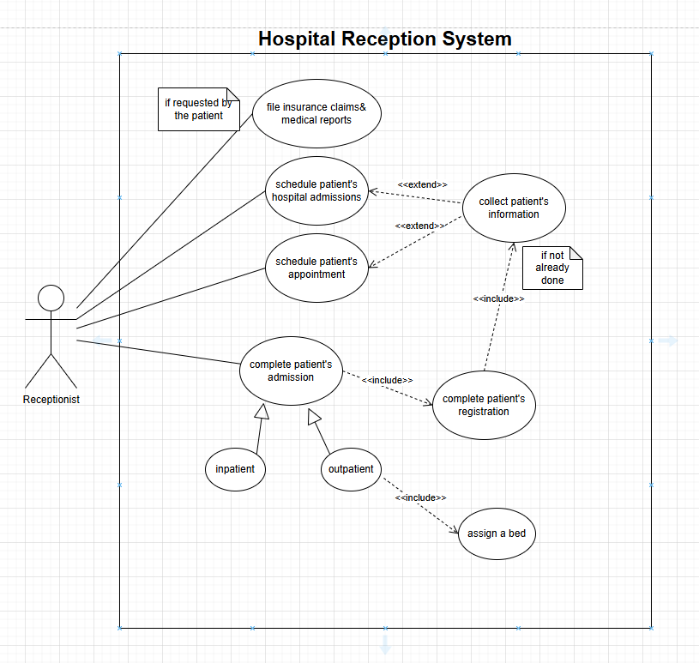

Fig 1 : Hospital Reception System Use Case Diagram